
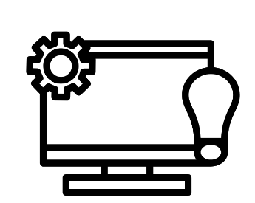
Willaston Computing Learning Journey
Spring 1

Fruit
Greetings
Summer 1

Drinks & Snacks

Autumn 1

Colours
Autumn 2
Feelings
Christmas

Spring 2

Numbers to 10
Summer 2

At the Seaside
Sequence of Learning Overview
Spring 2

Clothes

Year
1
Year
2
Year
3
Year
4
Year
5
Year
6
Autumn 2

Autumn 1

Spring 1

Revision of Verbs
Numbers to 50
Autumn 2

Telling the Time
Autumn 1

Buildings
Directions
Summer 1

Connectives
Breakfast

KS1 Spanish

Spring 1

Clothes
Food
Food Preferences
Summer 1

My Family

Autumn 1

Greetings
Names
Revision of Numbers 1-10
Autumn 2

Ages
Parts of the Body
Revision of Colours
Spring 2

My Family
Summer 2

Days of the Week
Months of the Year
KS2 French

Summer 2

My Home (Rooms)
Household Items

Summer 1

Family Members & Adjectives to Describe

Spring 1

Classroom Objects
Classroom Commands
Summer 2

Dates
Revision of Weather

Spring 2

Food
(Likes & Dislikes)
Key
KS1 Spanish
KS2 French

Spring 1

Family
Autumn 1

Parts of the Body
Summer 1

Verbs
Numbers to 30
Summer 2

Holidays
Weather
Spring 2

Pets
Autumn 2

Animals
Alphabet
Spring 1

Colours

Autumn 1

Greetings
Numbers 1-10
Saying How You Are
Summer 1

Snacks
Summer 2

Days of the Week
Months of the Year
Spring 2

Fruit

Autumn 2

Name
Age
Colours

