 Willaston Newsletter
Autumn Term 2
What a busy half term it has been! Lots of things have been happening at Willaston over the past few weeks – Wellbeing Week, STEM challenge, Christmas Performances and a visit from Father Christmas himself to name but a few!!


I would like to say thank you to the FWSA for helping to organise Christmas events this year – Elfridges, Father Christmas’ grotto and gifts and Tea/Coffee and Mince Pies at the many Christmas Performances. I know that they are always looking for volunteers and new members so please make you self known to them in the playground or via the school office.


Staffing
I’m sure you will welcome our new Site Manager – Mr Mark Addis, he has joined us this week and you will see him around the site every day.

As some of you may be aware, Miss Pickston got married recently, so her new name is Mrs Pickston-Graham! Congratulations to the newlyweds!

A few pictures of what our wonderful children have been up to this half term…
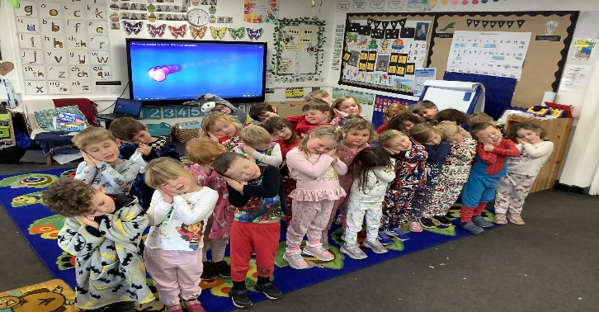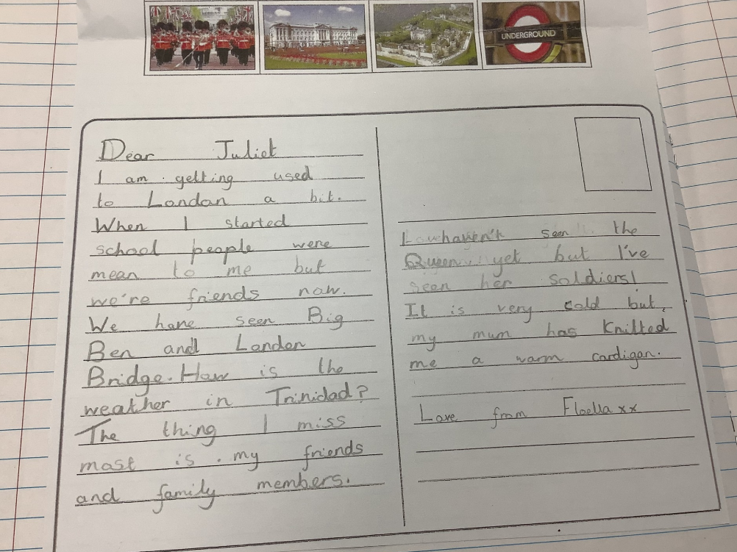

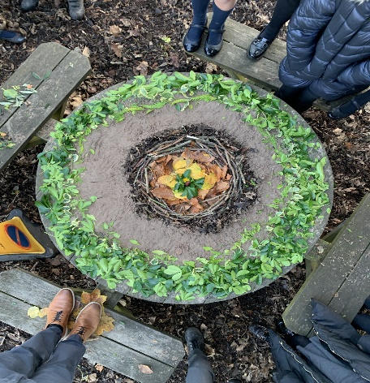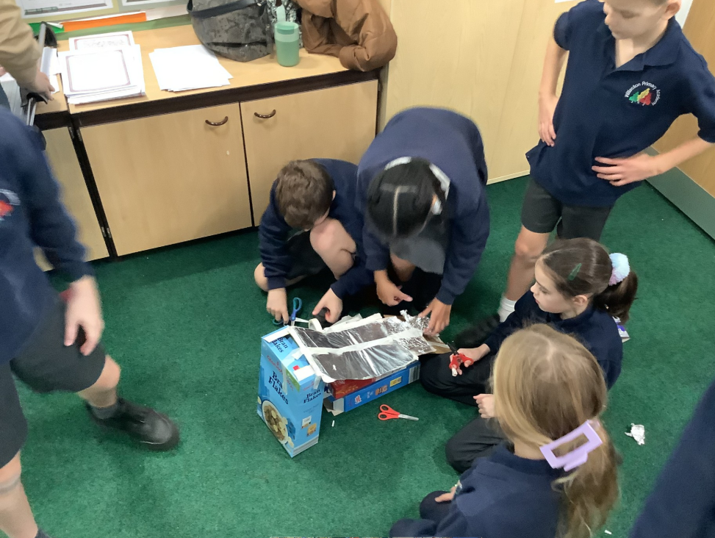

Parking
Please continue to be respectful to our neighbours on Derwent Close and Murrayfield Drive when you are driving and parking near to the school in the morning and at the end of the school day. The PCSO has visited this term, to check on where and how people are parking on these two roads in particular along with the speed that people are driving.

Dates for the diary
Dates have been sent out as an attachment to this newsletter. As always, further dates for your diaries may occur over the term or may be rearranged, but these will be communicated to you either by the school office or the class teachers themselves.

School Lunches
Please see attached letter regarding our new school lunch provider – Aspens. (This was previously sent out by email the week beginning 2nd December)

Reading for Pleasure
Attached to the newsletter email, there is a letter for all of the children with recommended reads, there are three non-fiction books, three younger fiction choices and three older fiction books. The School Council and Reading Champions from Year 6 have chosen these books to encourage reading at home.

Absence
Please can you ensure that you leave a message on the answer machine or an email to the office to let us know if your child is ill. This saves Mrs Bottomley having to ring around many families each day to check why children are absent from school.

Additionally, if you going away on holiday even if just for a day, you must fill in an absence request form.

With regards to appointments, if you have to take your child out of school during the day, please ensure that you provide evidence of your child’s appointment i.e.: letter, screen shot, appointment card.

Thank you…
A very big thank you for all of your support over this half term and I hope you and the children have enjoyed the many events that have been happening in and out of school. The staff work so very hard to ensure all of our children experience a variety of activities and I am very proud to lead a school which offers so many opportunities for our children.
I hope you all have a lovely Christmas time and I look forward to seeing you all on our return on Tuesday 7th January.
Merry Christmas and a Happy New Year
Miss Wright


