Phonics support
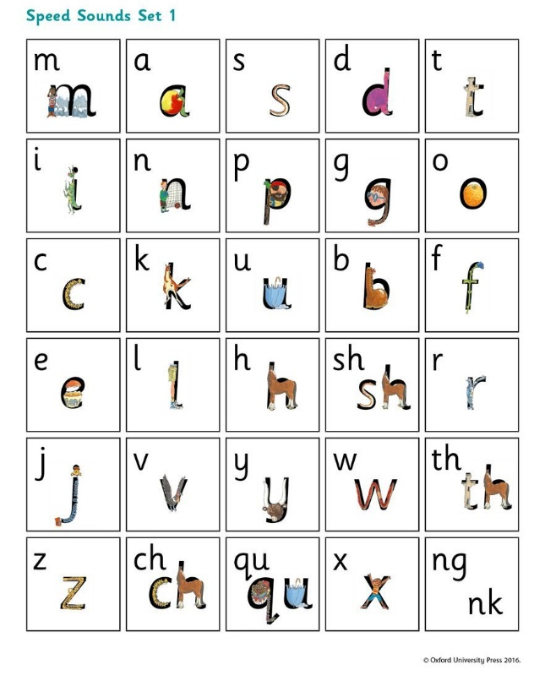
Set 1 Sounds
What can you do to help at home?
1. Use pure sounds, not letter names
2. Teach the picture names
3. Practise reading sounds speedily - ‘review, review, review’
4. Use the handwriting phrases for writing only.

Set 2 and 3 Sounds
What can you do to help at home?
1. Practise the sounds and phrases
2. Practise reading sounds speedily - ‘review, review, review’
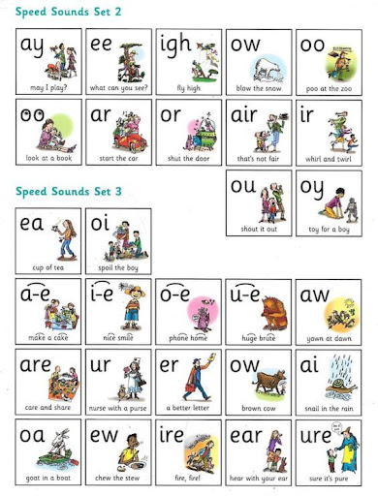
3. Use ‘Special Friends’, ‘Fred Talk’, read the word’ to read words.

