
Reading stories to your child
What can you do to help at home?
1. Read the same stories aloud again and again
2. Read with enthusiasm – love each story
3. Use a range of vocabulary with your child.
Suggested books good quality books:

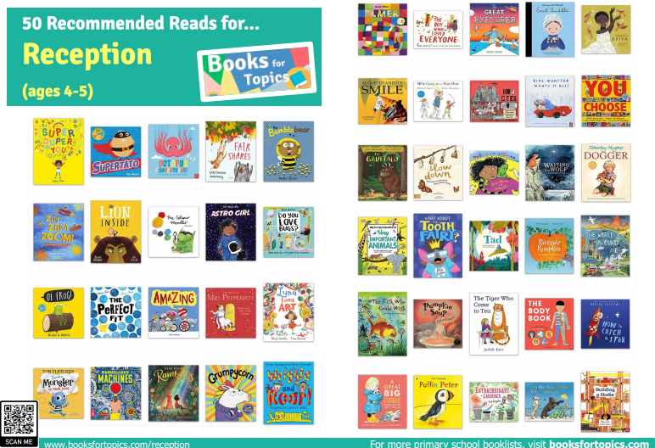

Listening to your child read
What can you do to help at home?
1. Listen to your child read the same Read Write Inc. Storybook again and again.
2. Encourage them to use ’Special Friends’, ‘Fred Talk’, ‘read the word’.
3. Discuss the story and encourage their storyteller voice.

